Paper template for the proceedings of THE 5th International SWBSS conference
First A. Author, Second B. Author, and Third C. Author

Keywords
SWBSS conference, Paper Instructions, Formatting, Template, Typesetting

Abstract
This document provides instructions for preparing a paper to be included in the Proceedings of the ‘5th International Salt Weathering of Buildings and Stone Sculptures Conference (SWBSS 2021)’. The first page is used only for the paper title, the authors' names and affiliations, keywords and the paper abstract. Your abstract must fit on the first page below the keywords; the next section of the paper must begin at the top of the second page.
These instructions are written using the paper template, so the paper can be typed directly in this document. The papers will be published in two formats: as an indexed PDF and as printed volume.

- INTRODUCTION
The proceedings will be published in PDF and distributed during the conference as a . It is the authors’ responsibility to correctly format their papers before submitting them.
For a paper to be included in the proceedings and to be presented, (1) it must be received by the deadline given on the symposium website and (2) at least one author must be fully registered to attend the symposium before the deadline for the submission of the revised paper, June 1st, 2021.
- Copyright and originality
By submitting their papers for publications, all authors are stating that the work submitted has not been previously published. Any material that is reused must be explicitly mentioned in the references.
The proceedings will be published under a Creative Commons Attribution 4.0 International (CC BY 4.0) license by BK Books, an imprint of TU Delft Open. TU Delft Open allows the author(s) to hold the copyright without restrictions. TU Delft Open allows the author(s) to retain publishing rights without restrictions. See for more information: https://books.bk.tudelft.nl/index.php/press/open.
- General publication specifications

All papers must be written and spell-checked in English (UK or US English is ok, as long as the writing is consistent). Papers should be edited for clarity and grammar before being submitted.
The page size is B5, 176 mm wide by 250 mm high. The page is divided into three text areas: the body, the header, and the footer.
The body is where all of the paper’s content is located. Its margins should not be altered.
The header is a single line of text with a 15 mm margin to the top of the page. The header is omitted on the first page of the paper. The footer is a single line of text with a 15 mm margin to the bottom of the page.
All text, including the title and author information, captions, and table contents should be in the Times New Roman font (sometimes called Times Roman or Times). The font styles are described below for different uses; this document can be used as a template for writing papers as it contains all of the styles described.
The minimum paper length is 4 pages; the maximum is 10 pages (including figures and references).
- First Page
The first page contains the paper title, the author(s) names and affiliations, keywords, and the paper abstract. The paper itself must begin at the top of the second page.
- Title
The title should be written left justified, in all capital letters, 14 point bold text, single spaced. Please use the style “Paper Title_SWBSS” in the template.
- Author
The authors should include their full names. They should be written left-justified, in 12 point bold text, single spaced. Please use the style “Author_SWBSS” in the template
- Affiliation
The authors’ affiliations (institution, address) should be given as footnote on the first page, written left-justified, in 10 point text, single-spaced. It is essential to indicate the corresponding author and his/her email address. Please use the style “Footnote_SWBSS” in the template. If authors have the similar affiliation, it only has to be mentioned once (e.g, A. Smith¹, B. Jones¹).
- Keywords
A maximum of five keywords that properly describe the paper's content should be provided. The title “Keywords” should be formatted as Heading 1, the keywords themselves should be formatted as Text.
- Abstract
The abstract must be descriptive of the paper’s content and must fit in the space on the first page below the keywords and above the author's affiliation footnotes. The title “Abstract” should be formatted as Heading 1 and the abstract text should be formatted as Text.
- HEADINGS
There are styles provided for two levels of heading. Given the length of the papers, the use of three levels should be avoided; if three levels are needed, simple capitalized headings in the body text style may be used. The headings must be numbered using the decimal system.
  - Heading 1
Heading 1 should be used for divisions between paper sections, and should be written left-justified in 12 point bold, all-capitalized text. There should be a 12 point space above and a 6 point space below these main headings. Please use the style “Heading 1 (main) _SWBSS” in the template.
  - Heading 2
Heading 2 is used to subdivide Heading 1 sections and should be written left-justified in 12 point bold text with capitalized words. There should be a 9 point space above and a 6 point space below these secondary headings. Please use the style “Heading 2 (secondary) _SWBSS” in the template.
- TEXT
Ordinary text should be written justified in 11 point text single-spaced both within and between paragraphs, in one column. Each paragraph should be marked by having its first line indented 6 mm. Please use the style “Main Text_SWBSS” in the template.
- Page Headers
The page header should be written in 10 point text, single spaced. Please use the style “Header and Footer_SWBSS” in the template. There is no page header on the first page.
  - Title Header
The full title of the paper should be placed on one line in the page header on even-numbered pages, starting with the second page, aligned left. If the title is too long to fit on one line, it should be abbreviated in a manner that retains its meaning.
  - Author Header
The authors’ names, given as initials and surnames, should be placed on one line in the page header on odd-numbered pages, starting with the third page, aligned right.
- Page Footers
The page footer should be written in 10 point text, single spaced. Use the style “Header and Footer_SWBSS” in the template.
  - Page Numbers
Pages will be numbered consecutively for the printed book. Therefore, page numbers should not be used in the individual papers when submitted.
  - Editorial Footer
The name of the conference (“5th International SWBSS conference – Delft 2021”) should be in the footer, aligned with the inside margin (alternating sides, right side of even-numbered pages).
- FIGURES
All figures should be numbered consecutively and captioned. The caption should be written left justified in 10 point text, below the figure. A 6 point space should separate the figure from the caption, and a 9 point space should separate the upper part of the figure from the text above, and the bottom of the caption from the text below. Please use the style “SWBSS_Captions” in the template.
Figures should be included in the text, close to where they are first referenced to rather than added at the end of the paper.

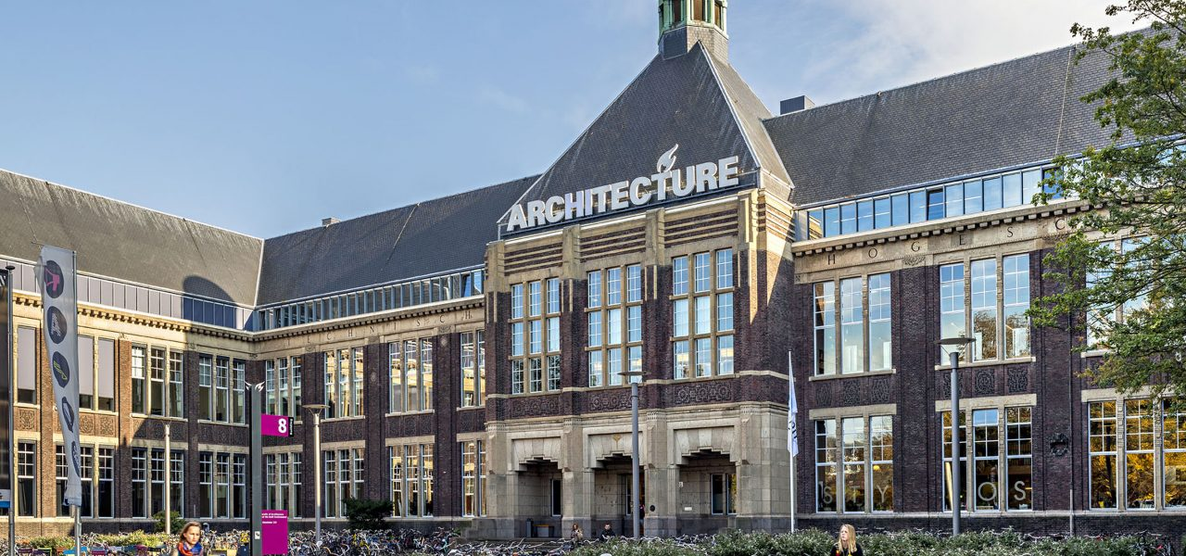
Figure 1: TU Delft - Faculty of Architecture.
- TABLES
Tables should be numbered consecutively and separately from the figures and captioned below. Table content should be written in 10 point text, using the style “SWBSS_Table” in the template. Table captions should be below the table with a 6-point space to the table; there should be a 9-point space below the caption and above the text.
Table captions should follow the same formatting as that used for figures, using the style “SWBSS_Captions” in the template.

 | Title A | Title B | Totals
Title C | 12 | 15 | 27
Title D | 13 | 17 | 30
Title E | 14 | 19 | 33
Totals | 39 | 51 | 90
Table 1: Example.
Where cell border lines are used, their width should be “hairline” or 0.05 point to make the table more legible.
- EQUATIONS
Equations should be numbered using Arabic numbers in parentheses. Numbering of each equation must be right aligned. Please use SI units.
The following example is a single line equation:
Ax = b | (1)
The next example is a multi-line equation:
F = ma | (2)
E = mc²
- ACKNOWLEDGEMENTS
This optional heading should be inserted just before the References heading.
- REFERENCES
References should be provided in the final paper section, listed in order as they appear in the text. Use the style “Reference_SWBSS” in the template, Pleas use the IEEE style. References should be cited in the text by number [#] between brackets. For more information visit: https://ieee-dataport.org/sites/default/files/analysis/27/IEEE%20Citation%20Guidelines.pdf

- CONCLUSIONS
Papers should be submitted electronically in .doc or .docx format to SWBSS2021@tudelft.nl.
Deadline for the submission of papers are reported on the conference website https://www.tudelft.nl/en/architecture-and-the-built-environment/current/events/swbss-2021.
The organizers do not commit themselves to include in the Proceedings any paper received later than the given deadline.

REFERENCES
[1] W. J. Quist, “Vervanging van witte Belgische steen: Materiaalkeuze bij restauratie,”, PhD thesis, Delft University of Technology, 2011.
[2] B. Lubelli et al., “Towards a more effective and reliable salt crystallization test for porous building materials: state of the art,” Mater. Struct. Constr., vol. 51, 2018.
[3] S. J. C. Granneman, B. Lubelli, and R. P. J. van Hees, “Mitigating salt damage in building materials by the use of crystallization modifiers – a review and outlook,” J. Cult. Herit., vol. 40, 2019.
[4] B. Lubelli, R. P. J. van Hees, and T. G. Nijland, “Salt crystallization damage: how realistic are existing ageing tests?,” in 3rd Int. conf. on Salt Weathering of Buildings and Stone Sculptures, 2014, pp. 259–273.
[5] S. Siegesmund and R. Snethlage, Eds., Stone in architecture - Properties, Durability, 4th ed. Springer, 2011.
[6] CEN, “NEN-EN 1926 - Natural stone test methods - Determination of uniaxial compressive strength.” 2006.

Institution of first author, address, corresponding_author@email.com
Institution of second author, address
Institution of third author, address

