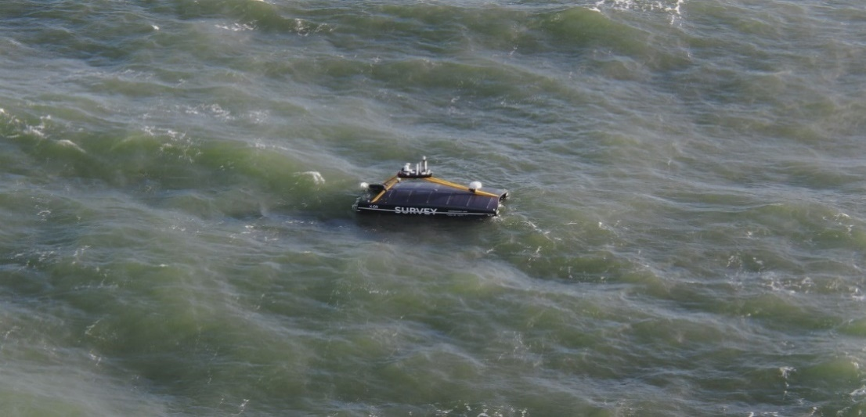

Figure 3: Uncrewed Survey Vessel acquiring multibeam data

Figure 2: Uncrewed Survey Vessel

acquiring multibeam data

Figure 1: Side Scan Sonar Data Example. Freespan missed in interpretation



**Faculty of Civil Engineering and Geosciences**

**Geoscience and Remote Sensing**

**Master of Science Project**

**Theme: Seafloor modelling**

**Predicting success of infrastructure mapping using machine learning to keep energy infrastructure safe and in operation**

**Description tasks**

The candidate will firstly perform a literature review on seabed morphology, side scan sonar interpretations and multibeam data to identify if any gaps exists.

There are two research objectives:

1. Distilling models of sea floor dynamics and correlating these with free spans is expected to result in free span prediction
2. Create a time lapse analysis of pipeline freespans to detect sudden changes indicating potential misinterpretations of side scan sonar data. Thereafter characterise the seafloor through a few parameters and correlate these with the sudden changes will focus side scan sonar interpretation efforts

**Requirements**

The candidate shall have good programming skills (MATLAB or Python), and sufficient knowledge (e.g. CIE4522) of fundamental principles of data processing and positioning.

**Information:**

[Katerine.Ryan@shell.com](mailto:Katerine.Ryan@shell.com), Sandra.Verhagen@tudelft.nl

**Background information**

Recent events in the global energy market have made Europe long for carbon- and autocrat-free energy. Countries around the North Sea are stimulating large development of offshore wind and gas exploration and production. What these projects have in common is that all infrastructure like cables and pipelines are on the sea floor which dynamics need to be better understood. In 2021 an incident occurred in the UK sector of the Southern North Sea where a gas pipeline was found to be “free spanning” over 80 meters. Free spanning is where the pipeline is not supported by the seabed, often due to erosion of the sediments around the pipeline. The implications were huge as gas production had to be shut in for 2 weeks (in winter time) and the pipeline had to be depressurised. This came at significant cost due to missed income as gas production targets or Greenhouse Gas emission targets could not be met. To prevent this from happening, yearly acoustic pipeline inspections are organised to assess the integrity of the pipelines, including freespan mapping. The yearly acoustic inspections are currently carried out using a combination of towed side scan sonar (SSS) and multi beam echo sounding (MBES). The interpretation of the side scan sonar can be challenging however, especially when the sea floor is “complex”, with significant scouring around the pipeline . Misinterpretation of SSS data can prevent adequate mitigation and may eventually lead to pipeline shut ins to accommodate remediation activities to reinstate pipeline support.

MBES data can be used to identify areas of difficult seafloor morphology based on a parameter such as slope. NAM holds over 15 years of pipeline inspection data including mapped freespan parameters and sea floor topography. The yearly mapping allows for time lapse analysis that can be correlated with freespan persistence and growing or decreasing free spans over time. It would also allow for distillation of parameters that characterise “difficult” sea floor that have a predictive value for successful mapping of free spans using SSS. Given the large volume of available data this can be used to train machine learning algorithms.

