

**Faculty of Civil Engineering and Geosciences**

**Geoscience and Remote Sensing (GRS)**

**Master of Science Project release date: October 2024**

**Theme: Wind turbines, precipitation and mesoscale modelling**

**Interaction between offshore wind farms and precipitation**

**Research questions**

In this study we would like to focus on how offshore wind farms influence precipitation in a numerical weather prediction model. To investigate this, we will perform simulations with the Weather Research and Forecasting (WRF) model and compare the results to observational radar data. This project will focus on the North Sea. We will investigate if the divergence and convergence is also observed within the numerical model.

**Students profile**

We are looking for a student who is interested in offshore wind and the atmospheric boundary layer. Additionally the student should be willing to perform simulations and analyse the data.

The student should have experience in a high level programming code like Python or similar. Additional knowledge in Fortran and Bash would be a plus as any knowledge in atmospheric dynamics and turbine aerodynamics.

By the end of this project you will have a good understanding of wind farm and precipitation modelling within WRF.

**Information:**

- Dr.ir. Sara Porchetta

- email: [s.p.porchetta@tudelft.nl](mailto:s.p.porchetta@tudelft.nl)

- room 2.34 (Building 23)

**Context**

In the coming years, a significant number of offshore wind farms will be deployed to meet global renewable energy targets. By the end of 2023, global offshore wind capacity reached 75 GW, marking the second-best year for installed turbines. Ambitions are even higher for the future; Europe alone aims to achieve 425 GW of installed offshore wind capacity by 2030. These developments will intensify interactions between wind farms and the atmosphere. Up to know it is not very clear how wind farms influence precipitation. This is important as changes is precipitation offshore can influence blade degradation of other nearby windfarms or influence the precipitation quantity or location onshore. Some initial observations indeed showed that wind farms induce convergence upstream of the wind farm and divergence downstream of the wind farm reducing precipitation onshore.

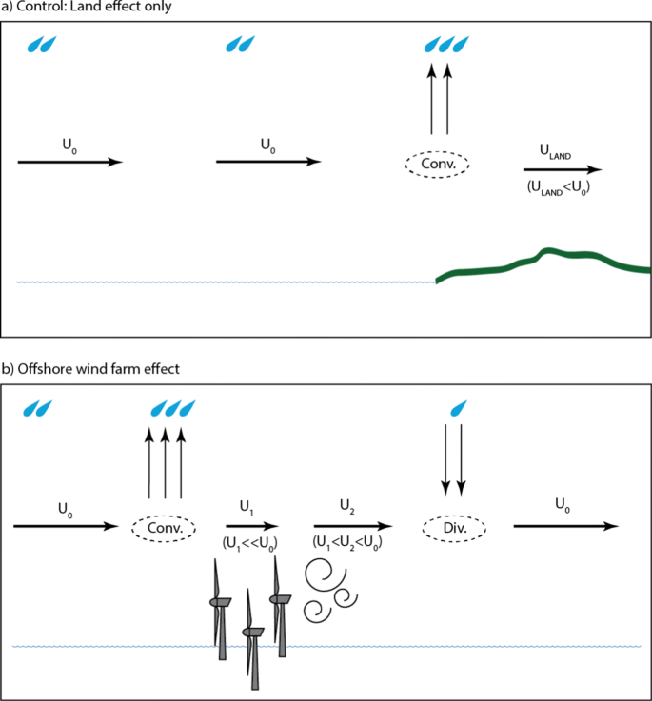

(Al Fahel and Archer 2020)