About Lely
Lely is an ambitious international family business with more than 30 facilities and customers in over 60 countries. We are the market leader in automated systems for dairy farmers worldwide and pioneers of robotic milking technique. With our ecosystem of robots, we feed and milk cows and keep the barn clean. These autonomous robots not are constantly gathering data through sensors that not only drive their own decisions, but also that of the farmer. With our T4C (Time for Cows) farm management software, we help the farmer make smart choices based on this data.
About the Astronaut milking robot
Lely’s Astronaut milking robots are designed for health and stress-free milking for cows. The cows visit the robot voluntarily for milking. The robot feeds the cow, finds the udder using the combination of a 3D ToF camera and Laser, and stars milking the cow using a robotic arm.
The robot recognizes the cow using RFID tags on her collar. This allows the robot to optimize its actions for that cow. It also checks the quality of milk by sensing a range of valuable indicators, such as mastitis, fat and protein content, and lactose. This not only ensures good quality of milk, but also helps the farmer keep the cows healthy.
The challenge: Cow recognition
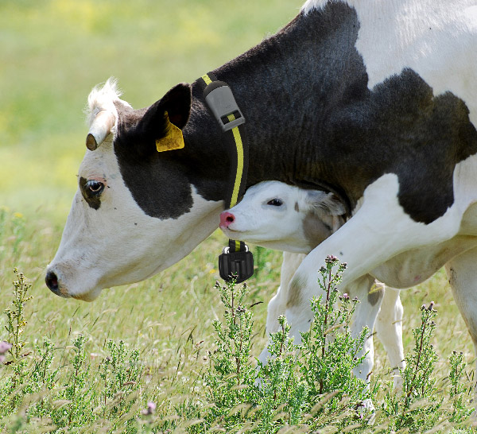
The collar tags can break down and require a lot of labor to replace. We believe that cows can be identified using machine vision instead-of or in-conjunction with the collar tags. Distinguishing features can be features of the cow’s body, numerical markings on the tags placed on cow’s ear, and numerical markings on her collar-band.
We challenge you to figure out the best way to identify cows. You are free to choose a new sensor, or make use of our 3D ToF camera. Thanks to the presence of these tags, ground truth data is easily available for machine learning and, to validate the results.

