Course Manual

TITLE COURSE
IOBx-xx

Name course coordinator

Table of contents
Table of Contents 2
Title 1 – chapter title 3
Contact information 4
Course description 5
Place of course in Curriculum 5
Learning Objectives 7
Course Materials 9
Student Responsibilities 10
What to expect from teachers 11
Assessment 12
Assignment 16
Course Outline 17
Deliverables 18
What should you do if you are ill? 19
Appendices 20

Text Styles – DELETE THIS PAGE
Title 1 – chapter title
Title 2 – sub title
Title 3 – sub-sub title
Text
- Text – bullet
Figure

Contact information
- Name course coordinator
- Office number
- Office hours
- Phone number
- Mailbox: Abbreviationcoursetitle-io@tudelft.nl

Course description
- Course content corresponding to the Coursebase information, however you address the students here (You will apply…), and this description can be more detailed.
- Didactics; you mention the education method (corresponding to Coursebase) here; you can make it more elaborate.
- Possibility in the course for students to decide on own choices.

Place of course in curriculum
- Semester vision (will be provided to you by the BSc team)
- Explain the reason of existence for the course (e.g., This course provides the basis of the domain knowledge on humans).
- Insert and illustrate the image of the curriculum with your course highlighted, which is provided by the BSc revision team (available on Sharepoint > background information> Coursebase, Course Manual, Brightspace>visual for each course)
- Mention the courses your course builds on (e.g., This course implements knowledge from Understanding People and Understanding Organisations)
- Explain which knowledge the course provides in relation to other courses (e.g. This course provides you with the Research skills needed for the following design projects)
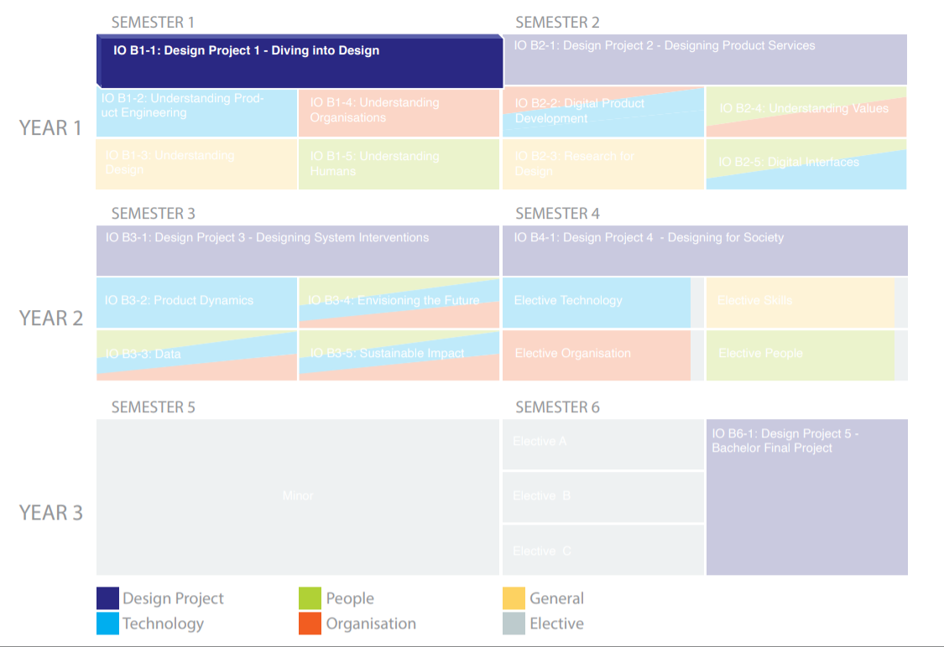

[Extra for the design projects:]
- Mention the quadrant the assignment is in (Jeroen is working on new titles for the different quadrants)
- Show the Knowledge Apply table to inform students about the connection to the Content Courses; indicate which knowledge of the content courses students need to apply in the design project

Learning objectives
- Make sure the LO’s in the course manual are the same as in Coursebase. Also indicate a reference per Learning Objective to the Final Attainment Levels. Example:

- Students are able to apply process models and methods appropriately for different design challenges in an iterative design process. (LO 1.1.3)
- Students are able to apply principles of statics, mechanics and dynamics in embodiment design. (LO 2.2.1 )
- Etc.

- For the electives indicate on which LO’s of the mandatory programme the Learning Objectives further elaborate.

The following topics can be put in the order of your preference.

Please note: The parts marked in yellow <are to be adapted to the situation of the specific course>, or are (information for the course coordinator that does not have to be included in the CM).

Course materials
- Literature
- Other readings (texts, reader, …)
- Other materials (e.g. online information; online lectures, websites, clips, instructions, …)

Student responsibilities
- Expectations on participation
- Homework, self-study
- In project work, include information on group processes
- Other responsibilities

What to expect from teachers
- What can a student expect from course staff and/or lecturer/teacher/coach in reference to the learning (teacher roles) and availability.

Assessment
(Make sure the assessment in the course manual is the same as in Coursebase.)

The assessment for this course consists of the following <summative assessment/summative interim assessments>, namely:
- <Name summative assessment 1
- If applicable [Name summative assessment 2]
- Etc. >

As well as these summative assessments, the course also offers formative assessments. These formative assessments are intended to give you and your lecturer insight into your progress: how far have you progressed in relation to the learning objectives, and what is still needed to achieve the objectives. Formative assessments do not count towards the final mark and are not compulsory. As formative assessments are part of the learning process designed by the lecturer, they contribute to achieving the learning objectives and successful completion of the course. You are therefore strongly advised to take part. The following formative assessments are offered:
- <Name formative assessment 1
- Etc.>

Calculating the final mark
<Name summative assessment 1> is assessed with (choose from these two options) <a mark rounded off to one decimal place / a pass, a fail or a fail with option to additional work.>
(If applicable) <Name summative assessment 2> is assessed with (choose from these two options) <a mark that is rounded off to one decimal place / a pass, a fail or a fail with an opportunity to upgrade.>
(Etc.)
The results of the <summative assessment / summative assessments> are taken into account when determining the final mark for the course. In doing so, the following applies:
- (Include in case of 1 summative assessment) In order to determine the final mark for the course, the mark obtained for the summative assessment will be rounded off in OSIRIS to a half or whole mark, in line with the faculty’s rules for rounding off marks. If the final mark is 6.0 or more, you have passed the course. If the mark is lower than this, read the information about resit opportunities.
- (Include in the case of more than 1 summative assessments) The final mark for the course is only calculated if a mark of at least 5.0 and/or a pass is obtained for all summative components. If this is not the case, the final mark ‘NVD’ (= niet voldaan, fail) is registered in OSIRIS.
- If you meet this minimum requirement, the final mark can be calculated. For this calculation, the assessments count as follows when establishing the final mark: <assessment 1 for .. % and assessment 2 for .. %, etc.> The final mark will be rounded up to a half or whole mark, in line with the faculty’s rules for rounding up marks. If the final mark is 6.0 or more, you have passed the course. If the mark is lower than this, read the information about resit opportunities.
- (In the event that an individual contribution has an influence on the mark of a summative component in group, include:) Although <summative assessment x> is done in a group context, you will receive an individual mark. The mark is calculated by including your individual contribution in the following way: <explain how the mark is calculated, and how the individual contribution has an effect on the group’s mark>

If you register for the course or the course exam but do not take part, ‘NV’ will be registered for the course/assessment component in OSIRIS. Your final result in OSIRIS will thus be ‘NVD’ (= niet voldaan, fail).
If you fail to participate in or submit a summative assessment, ‘NI’ will be entered. Your final result in OSIRIS will thus be ‘NVD’ (= niet voldaan, fail).

Consequences of failing to meet deadlines
If you fail to meet the submission deadline for a summative assessment, this has consequences. Every day that work is handed in too late, 1 point will be deducted from the mark for the late work. If you submit between 1 minute and 24 hours after the deadline, you are one day late and 1 point will be deducted. If you are two days late, 2 points will be deducted, and so forth.

How can I resit an exam/How can I upgrade my mark?
In the case of exams (only add if there is an exam):
In case you failed the exam or want to achieve a higher mark, for every exam a single resit exam is offered in the same academic year. The resit exam is offered in the next exam period, i.e. in week … of the academic calendar.
For the <summative assessment(s)>, not exams (only add if there are summative assessments that are not exams):
If for the <summative assessment/summative assessments> you obtained a mark between 5.0 and 5.9 and/or you received a fail with option to additional work, you have the right to an additional opportunity. With an additional opportunity, you can upgrade your mark to a maximum of 6.0 in the case of a numerical mark, or to a pass in the case of a ‘fail with option to additional work’. This additional opportunity will be determined by the course coordinator. You have until the next exam period (see academic calendar) to take and submit your additional opportunity. This additional opportunity must be submitted no later than <enter date> (must be in week 10 of the next term or in the Q5 resit period).

Inspection and discussion
After the mark for the <(interim) assessments> has been published, you have the right to inspect and possibly discuss your assessed work (within 20 working days).
<Explain here how the opportunity to inspect and discuss work is organised for the course>

Validity period of marks obtained
If the final mark for the course is 6.0 or higher, you have passed the course.
(Add if the course consists of more than 1 summative component)
If you have not passed the course with a final mark of 6.0 or higher and the course consists of several summative interim assessments, the following applies:
- The partial marks that you obtain are only valid in this academic year (i.e. in 202X/202X+1>). On 31 August <202X+1> any partial mark that have been obtained will expire.
- However, if the content and form of the course have not changed in the <202X+1/202X+2> academic year, the interim assessments that have been passed and/or for which a mark of 6.0 or higher has been obtained can be extended. These extended marks will be entered into OSIRIS at the start of the course, and will have a result date that is the same as the first day of the term in which the course starts.
- A partial mark can only be extended once.

Checking for fraud/plagiarism
We need to be able to assess students on their own performance. For this reason, checks for fraud/plagiarism are made in this course. For more information about what is meant by fraud/plagiarism, click here.

Suspicions of any form of fraud will be reported to the Board of Examiners. Should fraud be detected, no result for this course will be recorded in any instance, and the Board of Examiners may take measures such as excluding the perpetrator from one or more assessments at TU Delft for a certain period.

Assessment form/rubric
<insert assessment form/rubric>

Assignment
- Description of the assignments and deadlines of the deliverables

Course outline
- Show the Weekly planning. This is the ideal planning as defined by the teacher. Students can specify their detailed planning themselves. Use the Excel format. You can add or adjust elements, but make sure to mention:
  - The subjects treated per week
  - Required study time allocation per week/subject, and specified hours for contact time and self-study
  - What you expect students to do in self-study time and before when
  - Do not mention specific locations (studios/ lecture halls). This will be made available through My Timetable for students.

Deliverables
- Requirements
- Deadlines
- How to hand them in

What should you do if you are ill?
If you are ill, you are responsible for taking action. If you cannot be present because you are ill (or for any other reason), you are expected to inform the person with whom you have a meeting. If you have a coaching meeting, for example, you should inform your coach of your absence; and if you are working with a group on an assignment, you should report your absence to the group. Also check with your fellow students whether you have missed any important information, and be sure to update your planning to make up for the missed study hours
.
Formally registering as ill
There are a number of occasions when a formal report of illness is also required in the IDE illness reporting app. These are the following:
- The first contact moment of the course; this is when you confirm your participation in the course.
- Contact moments involving an activity that contributes to the final mark for the course, such as a (final) presentation or exam.

For this course, it is compulsory to register as ill if illness prevents you from attending on the following dates/times:
- First contact moment on … (enter date)
- Include other times and dates – to be filled in by course coordinator>

How do you register as ill in the IDE illness reporting app?
- Before 10 AM on the day that you are ill, go to: https://ziekmelding-io.tudelft.nl/Illnesses/IllnessPageLogin.html
- Select the course and the day for which you want to register as ill.

In case of long-term illness
If you are ill for longer than a week, contact your coach to discuss what should be done and how, in order to catch up with the planning. If necessary, the coach can discuss your situation with the course coordinator. You will be referred to one of the academic counsellors if need be.
You can also make an appointment yourself with one of the academic counsellors to discuss your situation and planning. Click here for more information.
Appendices
- e.g. Assessment instrument, former course evaluation results (explicate changes compared to previous course run)

Courses with 5 ECTS credits have a maximum of two summative assessments. DP courses with 10 ECTS credits have a maximum of four summative assessments.

