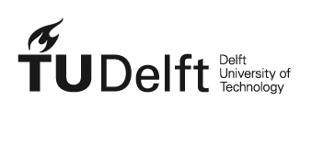
Delft, The Netherlands, 21 November 2022

Standard letter on unpublished work

To whom it may concerns,

Delft University of Technology has various repositories in which the output of the researchers and students is stored, disseminated and archived.

According to the Implementation decree on Doctoral Regulations PhD candidates are obliged to include their dissertation in the TU Delft Institutional Repository https://repository.tudelft.nl/islandora/search/?collection=research

Article 5.f of the Regulation states
‘The doctoral candidate is required to make a digital version of the dissertation (as a PDF file, or in some other agreed format) available to the University Library for inclusion in the Open Access TU Delft Repository.’

According to Delft University of Technology Faculty regulations, MSc students of TU Delft are obliged to include their work in TU Delft Educational Repository https://repository.tudelft.nl/islandora/search/?collection=education

The dissertations and MSC-theses contain original work that can be offered to a publisher at a later date, in an adapted form.

Delft University of Technology hereby declares that such content must be considered as UNPUBLISHED work.

Once a similarity checker (used to track plagiarism) identifies this work it should therefore not be seen as already published work. The editor of a journal should ignore overlap between the submitted paper and the original work in the dissertation or graduation work which are stored in Delft repositories.

If, for whatever reason, this Standard letter is still not sufficient for publishing a submitted paper, it is possible to put original work under embargo for some time (max 6 months) in order to prevent any conflict. As a result of that the work in the repositories can't be downloaded and only some metadata fields are still available.

If you have any questions regarding this Standard letter, please contact

Just de Leeuwe, MSc
Publishing Advisor|TU Delft Research Support|j.deleeuwe@tudelft.nl|+31 (0) 642165395

