Publishing Open Interactive Textbooks (OIT)
Step-by-step guide for lecturers during project phase (May – Dec 2023)
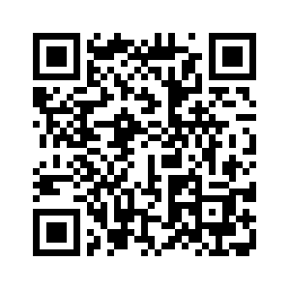
JULY 2023
- Decide if you want to publish your content as an open interactive textbook (OIT) in the Jupyter Books format:
> Look at some of the possibilities in the Demo book by scanning the QR code on the right.
> Publishing an open book gives you wide exposure and easy adaptability!
> TU Delft guarantees availability and there is support available in setting up your book!
QR Code to Timon Idema's Demo book
- Get in touch with the support team via interactive-textbooks@tudelft.nl. Discuss the options for your book and decide if an OIT is for you!
- Familiarise yourself with the quality checklist regarding use of CC license, plagiarism and publication policy. Make sure you agree with the conditions stated there.
- Set up a timeline, including:
  - Does your material need to be converted (from Word or LaTeX) to MarkDown?
  - Are there additional (interactive) figures to be developed?
  - Create TUD Gitlab, collect your files and software and move content
  - Develop and provide metadata content, e.g. summary, bio, keywords and ‘cover’ image
  - Decide if you would like text editing support
  - Check images and text for possible copyright or plagiarism issues.
- Discuss your timeline and support needs and set deadlines.
- Finalise the content of your book based on step 4 and 5, with help from the support team.
- Send a pdf version of your book to interactive-textbooks@tudelft.nl for a copyright and plagiarism check and go back to step 6 if needed.
- If you would like editing support, send a pdf version to the support team, who will contact the editor to do a spelling and grammar check. Implement input from editor if needed.
- You’re ready to publish your book!
Send all information, including catalogue information and a signed publishing agreement to the support team to publish your book on the OIT website.

When citing this document, please acknowledge it as follow: TU Delft Open Interactive Textbooks (pilot phase), 2023, https://textbooks.open.tudelft.nl/textbooks/about/about-itextbooks.

