Degradation Modelling Techniques for Offshore Power System Components
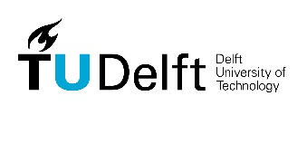
Supervisors: Donatella Zappalá
Co-Supervisor: Simone Mancini
Student: Akshay Antrolia

Background

As the world strives to achieve its sustainability ambitions through rapid offshore wind energy developments, innovation in wind farm operations and maintenance (O&M) offers a major opportunity to reduce the cost of clean energy production. Degradation modelling of offshore assets plays a large part in this reduction, as it allows for the creation of increasingly sophisticated O&M strategies that can adapt to technological and market-related challenges.

With more advanced tools and techniques to model component degradation mechanisms, asset owners could make reliable prognoses of the remaining useful life of key components, allowing them to schedule condition-based preventive maintenance interventions that reduce the risk of downtime (i.e. Loss of revenue) while avoiding the costs of unnecessary care. Similar approaches are relatively well established in the offshore Oil & Gas sector thanks to the long experience acquired in the past century. But this is not yet (fully) the case for offshore wind, where high-quality asset management research is required to expand current modelling capabilities while dealing with the challenges of availability, quality, quantity, and ownership of operational data.
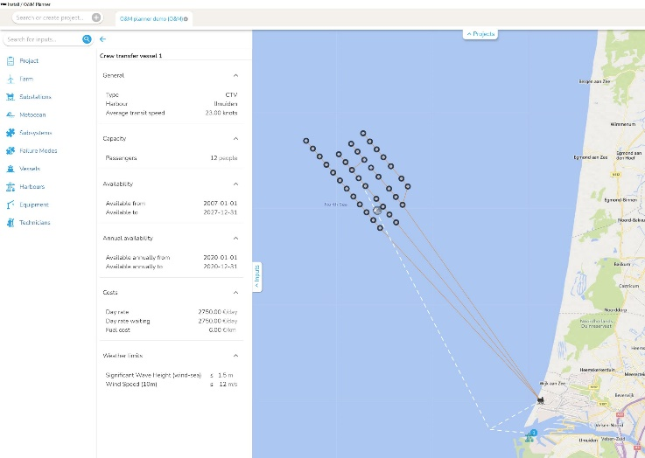
Figure 1: UWISE O&M Planner
Further, TNO is working together with a manufacturer of Offshore Floating Solar (OFS) systems that is currently deploying a prototype in the North Sea. However, this technology is still at its infant stage of development (existing assets are in inland waters only!) And there is great urgency to increase its Technology Readiness Level and be ready for full commercial application by 2025-2026.
Objectives
In this context, TNO has been asked to devise and suggest effective maintenance strategies for these assets before they are deployed at full scale. That is why TNO has decided to develop a degradation modelling framework to find optimal inspection/repair intervals for these assets. This project is aimed to design a degradation modelling framework which is flexible enough to be applied to different types of subsystems, including offshore floating solar and wind turbine components (e.g. to design cost-effective condition-based maintenance policies). This will allow the tool to be used for future R&D projects as well, hence maximizing the benefit achieved.
Ultimately, the work will facilitate the design and business case assessment of smarter O&M strategies for more effective and efficient offshore asset management.

