Background
Modelling floating offshore wind turbines (FOWTs) is difficult since the turbine's aerodynamics and the floating platform's hydrodynamics are strongly coupled. The scaling mismatch between the Reynolds and Froude numbers that arises from operating in the two fluid domains of air and water presents a further obstacle for physical testing at scale. To reduce floating wind energy costs, designers are using high-fidelity numerical models to replace full-scale modelling of FOWt, which are too expensive. The numerical engineering tools that are commonly employed for FOWT modelling are presently deemed as mid-fidelity to low-fidelity tools, as they do not possess the necessary level of accuracy. Moreover, operational FOWT data are not readily available for additional development or validation. High-fidelity tools, such as CFD, have greater accuracy but are cumbersome tools and still require validation.

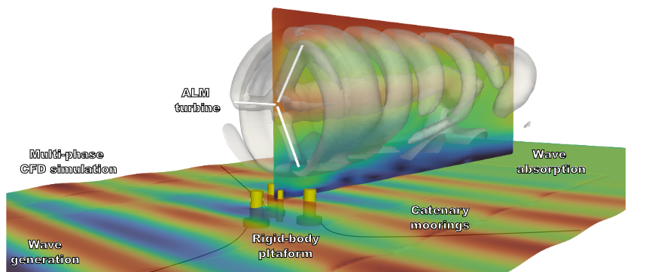
To validate numerical models, experimental models are needed. Another way of model FOWT is to do hybrid testing. In the context of experimental campaigns that are being led by TU Delft, the goal is to observe a fully coupled motion of a FOWT and the coupling between the floaters motion and the rotor aerodynamics and vice versa.
Figure 1: Final framework representation.

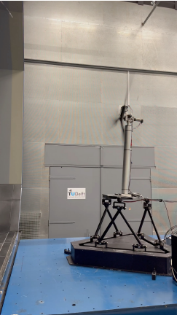
Objective
A floating offshore wind turbine is a complex technology with additional effects playing a significant role compared to bottom fixed wind turbines.
The focus of this study is to expand the already available model and validate it, especially the aerodynamics part, against experimental data of TU Delft hybrid experimental campaigns. Based on these campaigns the strengths and the limitations of the numerical model will be assessed. If the results are promising, a fully coupled model will be developed and validated as well.
Figure 2: Experimental setup of hybrid testing at TU Delft

