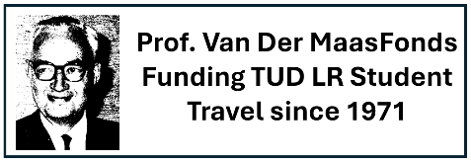
Application form for student travel funding from Van der Maas fonds

(Keep answers short, don’t change lay-out and do not add pages,
total form should fit on the given two pages.)

Send this form to: profvandermaasfonds@tudelft.nl

Full name: ………………………………………………………………………………………………….

E-mail address: ……………………………………… @student.tudelft.nl

Student number:……………………… City (of residence): …..…………………………………

Dates of trip: ………………………………… till ………………………………………… (dd-mm-yyyy)

Destination (university/company/institute, city, country):

………………………………………………………………………………………………………………

Select and complete the following:

☐ I am a TU Delft Aerospace Engineering student and a

☐ BSc student, started BSc programme in year ………………….

☐ MSc student, started MSc programme in year ……………….…

MSc track/profile: ………………………………….. / ……………………………………………………

Travel is in context of:
☐ Minor abroad (BSc)
☐ Internship (MSc)
☐ MSc thesis work (e.g. conference)
☐ Other ………………………………………………………………………………………………

Confirm these statements by ticking the boxes:
☐ I have not previously received funding from Van Der Maasfonds
☐ I have not obtained external funding (= not own or family) from other funding
schemes such as Erasmus, UfD scholarship, IRP, IDEA Leagues, Holland Scholarship,
JvE, STIR fund, etc. for costs associated with this travel
Motivation/Information:
What is the purpose of the trip? How does it help related to your study? What is the topic? (Recommendation letter(s) in pdf can be appended but are not required.)

……………………………………………………………………………………………………………………

……………………………………………………………………………………………………………………

……………………………………………………………………………………………………………………

……………………………………………………………………………………………………………………

……………………………………………………………………………………………………………………

……………………………………………………………………………………………………………………

Estimated costs in Euros:

Travel: ………………………………………….. Stay: …………………………………………..

Total estimated (incl. above and other costs): …………………………………………..

Requested funding from Prof. Van der Maasfonds: …………………………. (max € 1.000,-)

Bank information:

IBAN bank account: ……………………………………………………………………………………….

☐ I declare that everything I have stated in this form is true.

Sign here, send a scan as pdf to: profvandermaasfonds@tudelft.nl

Place/date: Signature :

