Characterisation of wind turbine blade dynamic loads under normal and fault conditions.
Supervisor: Dr.Donatella Zappalá
Student : Oleksandr Chernyavskii
MSc Track : Sustainable Energy Technology (SET)

Background
In our battle with global warming, people have developed various methods to tackle the problem. One of these methods is utilizing renewable energy sources for generating electricity. Wind energy has shown promise in the past couple of decades, with newer and larger wind turbines being installed both on and offshore.
While the initial investment to develop a wind turbine is large to begin with, operation and maintenance (O&M) costs should not be underestimated. O&M may account for up to 30% of the levelized cost of energy for offshore wind turbines, where each turbine component requires maintenance in one way or another. Wind turbine blades are the most expensive components of the turbine and may account for up to 25% of the total costs of the turbine [1]. This means that if a blade fails, replacement will be tremendously expensive.
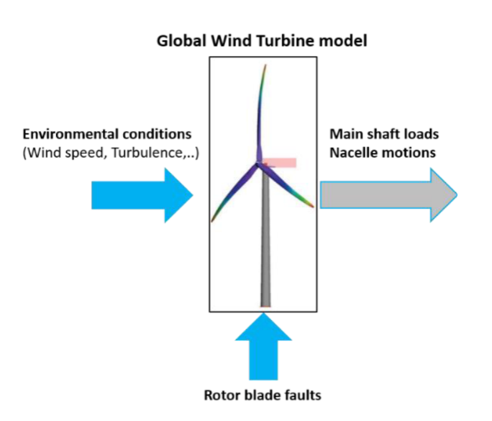
Problem description
Blade maintenance currently relies heavily on visual inspection techniques. While it can identify visual issues, it is often difficult to check for other potential problems, such as internal damage, microcracks. Early detection of any such damage provides leverage to plan maintenance, which may help prevent premature blade replacement. Therefore, it is crucial to research more advanced inspection and monitoring techniques [2].
Current research is aiming on the development of non-intrusive monitoring approaches for the structural integrity of wind turbine blades. Investigating the structural responses of wind turbine blades, valuable information about their health can be revealed, which then can be used as input for a structural health decision making tool.
Goal
The objective of this project is to monitor and diagnose structural responses derived from damaged blade conditions. Different types of damage, such as surface cracks or delamination, will be investigated and modelled by either altering structural blade properties in low-fidelity models (like one-dimensional Finite Element Model) at a desired location or by introducing more sophisticated high-fidelity methods, like three-dimensional Finite Element Model (3D FEM). The developed damage models will be combined with existing numerical solvers (like OpenFAST) to analyse the rotor dynamic load response under blade’s healthy and faulty conditions. A DTU 10 MW wind turbine will be used for the execution of this project.

References
[1] Li, D., Ho, S.-C.M., Song, G., et al. (2015). A review of damage detection methods for wind turbine blades, Smart Mater. Struct., 24, 3, 033001 doi:10.1088/0964-1726/24/3/033001
[2] Du, Y., Zhou, S., Jing, X. et al. (2020). Damage detection techniques for wind turbine blades: A review, Mechanical Systems and Signal Processing, 141, 106445, https://doi.org/10.1016/j.ymssp.2019.106445

