Investigation of wind turbine blade faults using drivetrain signals

  - Introduction
Blades are structurally-critical components of wind turbines. Depending on their size, their manufacturing costs range between 10% and 20% of total manufacturing costs [1]. Over their service life blades can suffer from factors such as material degradation and fatigue, which can limit their effectiveness and safety. In addition, blade damage is among the most expensive type of damage to repair and can cause serious secondary damage to the wind turbine system due to rotating imbalance created during blade failure. For example, rotor imbalance can not only reduce the aerodynamic efficiency of the turbine, and therefore its power output, but can also lead to very large increases in loading on the drivetrain, blades and tower. Therefore, it is imperative to perform an active and timely monitoring of the blades in order to identify incipient problems before they lead to catastrophic failures. The ability to detect damage in wind turbine blades is of great significance for planning wind turbine maintenance and continued operation [2]. In the wind industry, blade monitoring is often performed by highly qualified technicians during onsite inspections. In most of the cases this implies physical access to the blade, long turbine downtime, significant added costs, hazards and risks for the maintenance crew, especially offshore. The objective of this master project is to use drivetrain high frequency condition monitoring signals, that are available from standard instrumentation already installed on utility-scale modern wind turbines, for rotor fault detection and diagnosis. By using a decoupled analysis approach, which employs two separate models for simulation of the turbine dynamic response to aerodynamic loads (OpenFAST [3]) and of the dynamic drivetrain response [4], the project will investigate to what extent drive train monitoring signals are sensitive to blade damage and how effective they are in remote online detection and location of early blade failures. The project will focus on the simulation and analysis of the drive train dynamic response (Figure 1) building on the simulation results of the blade dynamic loads under healthy and faulty conditions obtained from another MSc project.
  - Activities
- In the simulations blade aerodynamic loads will be coupled to a drive train model in SIMPACK to extract virtual monitoring sensor signals, e.g. vibration response of the main bearing (work in collaboration with researchers at NTNU);
- Study the impact of the simulated rotor faults on the drive train signals;
- Implement standards signal processing and machine learning algorithms for the detection of various blade failure modes, such as delamination and crack propagation;
- Identify the most critical drive train monitoring signals for blade damage condition monitoring.
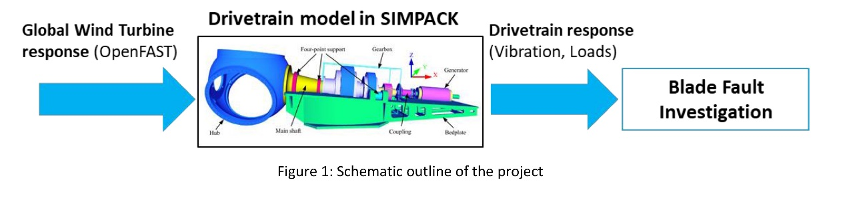

  - References
[1] Li, D., Ho, S.-C.M., Song, G., et al. (2015). A review of damage detection methods for wind turbine blades, Smart Mater. Struct., 24, 3, 033001 doi:10.1088/0964-1726/24/3/033001
[2] Du, Y., Zhou, S., Jing, X. et al. (2020). Damage detection techniques for wind turbine blades: A review, Mechanical Systems and Signal Processing, 141, 106445, https://doi.org/10.1016/j.ymssp.2019.106445
[3] https://openfast.readthedocs.io/en/main/
[4] Wang, S., Nejad, A. R., & Moan, T. (2020). On design, modelling, and analysis of a 10-MW medium-speed drivetrain for offshore wind turbines, Wind Energy, 23, 1099–1117, https://doi.org/10.1002/we.2476.

