Flagship: Behavioral Insight for Climate Action – Behavioral Design for Climate Action
To address climate change and encourage the adoption of climate responsible behaviours, communities of end users need to be engaged. Yet, often individuals act according to their short-term best interests, for instance, using unsustainable products or practicing behaviors that hinder achievement of climate goals. Design research plays a vital role by engaging users at the community level, and creates awareness of common resources, sense of community and joint efforts required for a successful climate action. We will focus on understanding how climate-resilient communities are shaped, given the interrelationships formed by common resources. And in this way contribute to the fundamental design knowledge and methods for understanding and shaping climate actions at the community level. Given the increasing complexity of multi-actor systems, there is a need to further develop field-based methods, like Living Labs, to provide insights that foster interactive designs, enable user-centric testing of assumptions and iterative redesign leading to an increased adoption of interventions for climate-aware behavior. An understanding of the social, cultural, economic, and ethical values of relating to climate action will be valuable here.

About Carissa Camplin - Assistant Professor of Spatial Planning and Strategy.
I apply urban toolkitting as a design practice to engage a broad range of actors in the co-creation of models, technologies, games and methods used to inform spatial planning practice. My research is imbedded in the Behavioural Design for Climate Action flagship project of the Climate Action Programme at TU Delft. I am particularly interested in the application of historical and nature-based approaches as guiding principles for future collective action and the use of common resources.
I engage in transdisciplinary research within the DeSIRE programme, 4TU. Center for Resilience Engineering and serve as member of the Resilient Delta Initiative Methodology Taskforce.
Contact details:
c.j.champlin@tudelft.nl
Faculty of Industrial Design and Engineering
Group of Human-Centered Design, Design Conceptualization and Communication
Landbergstraat 15

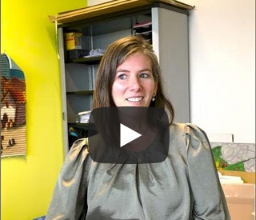
> Clarissa introduces herself and her flagship

