Delft Global Implementation Support Call
Creating impact in LMICs through Operational Experiments

The TU Delft | Global Initiative is the portal, platform and booster of science and technology for global sustainable development at TU Delft. We actively support researchers and students working on solutions that contribute to reaching the UN Sustainable Development Goals in and together with low and middle income countries. ‘Delft Global’ aims to generate true impact with its research and education activities.
To support the development of ideas resulted from needs analyses, knowledge exchange, research and co-creation, further into viable prototypes, we now start the Delft Global Development Support Call.

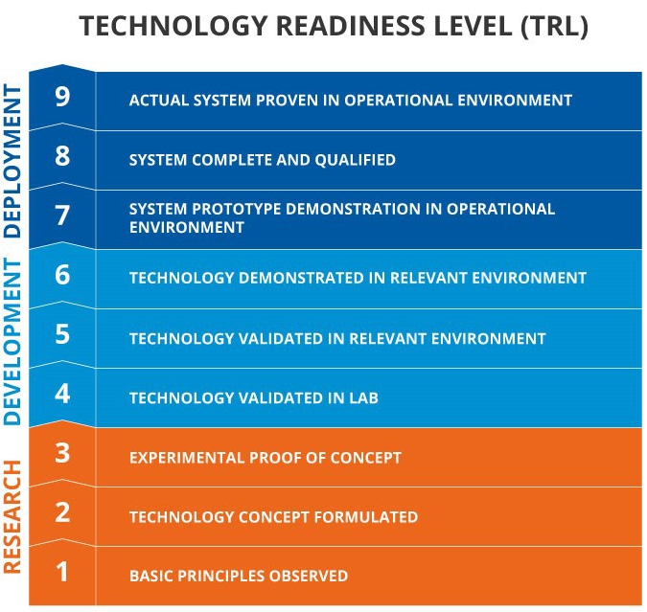
Level up! From TRL 6 to 7
The aim of the Delft Global Implementation Support Call is to push field experiments (Level 5/6) one step up onto the Technology Readiness Ladder to the Deployment (Level 6/7). In other words, what do you still need to understand or prove to start up production and distribution of the newly developed concepts? At level 5/6 you will have demonstrated that your basic prototype works in the relevant context and it is likely that the new concept can be integrated in existing operational systems. To get one level higher you want to setup an experiment to validate the system integration in the field.
Typically TU Delft Research leads to concepts that could be developed into newly (commercially) available products and services. Companies or possibly organisations such as NGOs, Governments or IGOs take the steps to deploy these. As DGI researchers are working with complexity and high risks in emerging markets, it can be challenging to find interested deployment partners or for start-ups to find investors. The Delft Global Implementation Support Call would allow for further validation of the new concept and thus reducing the risks for next steps by these deployment partners.

Critical conditions to qualify for Implementation Support will be, apart from the quality of the project itself:
- the engagement of commercial partners (existing company or start up team);
- a clearly defined next step after the proposed field experiment was successful. E.g. to apply for a NWO Take off Grant or some other type of grant or investment;
- a fit with the DGI Strategy (themes and/or regions).

The aim is to grant 5 applications per year and have a continuous opening of the call throughout the year. People can request between € 5.000 and €10.000.

Ultimate goal with this call for TU Delft | Global Initiative is to facilitate impact with research on people’s lives in Low and Middle Income countries. Science for the Benefit of People. All people. Worldwide.

1. Guidelines for applications

Who can apply
Researchers and students from TU Delft, who have oriented a research or graduation project to one of the TU Delft | Global Initiative themes in one of the target LMICs in Sub-Saharan Africa and South-East Asia. Students can only apply together with TU Delft staff.

Type of funding
- You can apply for funding up to 10.000 €
- This money can be used to hire temporary research staff and/or student assistants, travel, as well as for materials and/or prototype development.

2. Evaluation, Conditions & Timeline
Deadline and submission
Deadline for submission: Applications can be sent in throughout the year, ultimately until November 30.
Applicants will be informed on the outcomes before December 15th.

How to apply?
Send your application (max 2 pages A4, PDF) to delftglobal@tudelft.nl, with in the subject line ‘Application Delft Global Development Support Call’.

Evaluation
All submitted proposals will be evaluated by an evaluation committee (Claire Hallewas, Roel Kamerling and one of the Delft Global Steering Committee members connected to the theme).
The committee can decide to 1. Grant the application, 2. Ask for adjustments/additions according to their feedback (before a stated deadline) 3. Reject the proposal if it does not meet the criteria.

Conditions
The proposal should describe:
- How the project will demonstrate the feasibility in the relevant environment
- What the next step for the project will be after the (successful) experiment
- Who is going to be the (commercial) Deployment partner of the project and how they are involved in the project

In general the Implementation Support project should comply to the Delft Global approach: Addressing global challenges with high-quality science in close cooperation with local partners resulting in tangible and sustainable technological solutions. Focus regions: LMICs in Sub-Saharan Africa and Southeast Asia.

3. Guidelines for the Proposal

Project proposals are strictly limited to 2 pages A4, font Arial 10 pt., and should be submitted electronically as PDF. Feel free to include images, they can help your case.

- Name of the Delft Global Development Support project

- Applicant(s)
Main applicant: name, contact details
Co-applicant(s) (TU Delft staff): name, contact details
In case Main applicant is a student, make sure that the co-applicant is TU Delft staff.
Project code to transfer the grant to, in case of approval:

- Summary of your Development Support project
Short description of what you aim to do, in what phase the project currently is. What has been proven already and what would you aim to prove? How will your experiment do that? What will be the follow up? Why will that have a higher success chance after this experiment? [100 words]

- Collaborating Partners
With whom do you collaborate (name other collaborators outside TU Delft) ,why and how are they involved? Partners for the experiment and the deployment partner(s).

- Project description

Objectives:
What are the goals of this project?

Approach:
Which activities are performed?
How does your project fit in the Delft Global approach and strategic themes/regions?

- What’s next?
What will be the impact of this project and what will be the follow-up?

- Budget
Table with different type of costs and with possible (in-cash/in-kind) co-funding of partners.

4. Contact

For more information please contact:
Roel Kamerling, Program developer, TU Delft | Global Initiative, R.Kamerling@tudelft.nl

