FG: 29 june 2020

Thesis description for Symphony wave power generator.

Wave energy is widely available along the coast. For the Dutch coast the waves are different than from the ocean coast. Teamwork Technology, (https://teamwork.nl/) the company developing the symphony wave power device has made a special design for the Dutch coast. (https://symphonywavepower.com/ ) For this device a turbine was designed build and tested. (still on going) Although the turbine performs well building it showed complexity that they would like to improve on in the next design. Most of the complexity had to do with the generator size and position (below the turbine). Work is ongoing for the future up-scaled design of the turbine and generator. Also work performed on the type of generator to be used by Djurre Wikkering, a electrical engineering student from TU delft showed, that the ideal generator would be an ironless stator generator. (documented : xxx). These kind of generators are known but not available off the shelf for this application.

The opportunity of designing our own special purpose generator gives not only the possibility te have an efficient generator. It also gives an opportunity to integrate in into the turbine design so that the whole design is efficient, low maintenance and cheap in mass production. Below three examples are given on how the generator can be integrated, the left is the traditional way. The turbine is connected through a coupling on to the generator on top of the device. The second is that the generator fits within the core of the turbine. The third is a flat design that fits on the same shaft.

To be able to make such a design, the student needs to understand the operation of the whole device and the typical characteristics of waves. And even the differences in waves between ocean and seas like the North sea.
For this the student will be part of the on-gong program. In this program the design is made and testing is done. During the next half year the turbine is build-up in a test setup and tested extensively as if it was part of the device standing underwater at sea. This test setup is part of an EU program. The team has much knowledge on the design and the behaviour of the turbine and will assist the student with new design.

The on-going testing is performed at a level of up to 20kW. The future turbine and generator will need to perform on a level of 100 – 250kW.

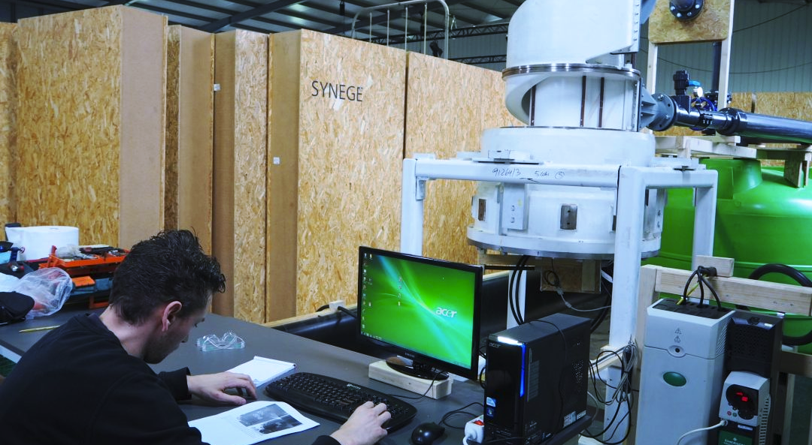
ongoing testing of the turbine and generator

Tasks:
- Review the report of Djurre Wikkering on the ironless generator theory (graduated at TU Delft)
- Study methodologies of design and building of this special type of generator.
- Understand the environment in which the turbine has to perform.
- Understand the control theory and the performance needed to function whit in the symphony system. See work of Ilias Sfikas (graduated at TU delft)
- As the device is submerged equipment need to be simple and robust. Recommend power electronics that are very basic and perform well for the control, but that have very low risk equipment in the underwater control box. For this a basic design of a underwater grid with up to 50 device (5 MW) connected in an array, should be made.
- Make a good basic design of a generator, that can be best integrated in the future turbine.
- Calculate efficiency of the turbine, generator and the grid up to the central connection point.
- Defend the design decision made on above issues.

